Chatham House
Losing the fight against graft
https://www.chathamhouse.org/publications/twt/losing-fight-against-graft
Robert Barrington

For example, Russia’s view has been that moves to tackle corruption should not prevent the corrupt accumulation of money and power by those close to the Kremlin. Equally, China’s view has been that its companies should be free to operate corruptly in other countries, and that external comment was ‘interference’ and not welcome about either China’s companies or China’s domestic corruption, including the personal enrichment of senior party officials.

More recently, strategic corruption has come to encompass subjects as diverse as interfering in foreign elections and securing strategic trade deals through corrupt transactions. Russia and China are most often cited as the guilty parties, which chimes with their reputation as ‘blockers’ in the formal UN Convention Against Corruption, or UNCAC, processes.

Elsewhere in recent months, there has been the Trump administration’s allegation that the World Health Organization is under Chinese influence. Looking more deeply at developments in the anti-corruption framework, analysts pinpoint two things. The first is a small wrinkle at the Organization for Economic Cooperation and Development, or OECD, but perhaps an important gesture of intent. A senior figure from the OECD system has noted the surprising seniority of the Russian representation at the OECD Anti-Bribery Working Group. ‘The US are not pulling their weight,’ this person says, which means ‘the Russians are certainly feeling much stronger... they feel a chance to take power.’

More obvious has been the increased presence of Russia and China at the UN’s International Anti-Corruption Academy, or IACA, based in Austria. In the past couple of years, the posts of chair and vice-chair of the Board have been filled by Russia and China respectively. The financial contributions from Russia and China dwarf those from most other countries. Why show an interest in the academy, a relatively obscure part of the UN system?

Likewise, China believes that UNGASS should ‘oppose the infringement of other countries’ sovereignty and interests through such practices as long-arm jurisdiction’, a direct challenge to the extraterritoriality of the US’s Foreign Corrupt Practices Act and other western anti-bribery legislation.

Foundation for Strategic Research
Russia’s policy towards Belarus during Alyaksandr Lukashenka’s fifth presidential term
https://www.frstrategie.org/en/publications/notes/russia-policy-towards-belarus-during-alyaksandr-lukashenka-s-fifth-presidential-term-2020

Russia has engaged in a more aggressive policy toward Belarus since 2014 to reinforce its power and influence over its neighbor at a time where Minsk was starting to be wary of deepening ties. Moscow’s strategy in the soft power, economic and military realms has been largely self-defeating. Lukashenka, as an authoritarian leader first and foremost concerned by his own survival, fears that giving up too much sovereignty in return for too few benefits provided by Russia would jeopardize his leadership. He has thus taken gradual steps to bolster his country independence and sovereignty by limiting its dependence on Russia through the diversification of the country’s ties. While the extent to which Minsk can distance from Moscow is questionable, it is clear that the relations between the two states will remain conflictual during what is set to be Lukashenka’ sixth presidential term, further undermining the unity of the « Russkiy mir » advocated by Moscow as long as it maintains a coercive approach and neglect Belarus’ interests.

Taking into account this dynamic and the protests which occurred on the eve of the Belarusian 2020 presidential elections, Lukashenka might be looking to deepen ties with China to receive economical and ideological support for its authoritarian regime. In turn, the growing bipolarization of the international system between the United States and China amidst the coronavirus pandemic might create momentum for Beijing to expand its interests in engaging with Minsk as it seeks to expand its influence. This would increase Beijing’s presence at the European Union’s borders and pose a tough choice for the EU: it might have to gloss over Minsk’s violations of electoral standards and avoid re-imposing sanctions as it might accelerate Belarus’ turn to China. Belarus is undergoing a transition in its domestic and foreign relations and the European Union must be able to carefully balance its policy toward Minsk in the aftermath of the 2020 elections.

독-러 가스관, Nord Stream 2
Nord Stream 1은 2011년 완공 후, 사용 중에 있다. Nord Stream 2는 독일과 러시아를 직통으로 잇는 두 번째 가스관이다. Nord Steam 1과 2는 모두 폴란드와 우크라이나를 거치지 않는 가스관이다.
Nord Stream 2는 2018년 독-러 간에 협정이 체결되었다. 동년에 핀란드와 스웨덴 해협 이용도 허가 받았으며, 2019년에 덴마크에도 허가를 받았다.
Nord Stream 2는 러시아 Ust-Luga에서 독일 Greifswald까지 이어진다. 길이는 약 1200km로 현재 완공까지 160km가 남은 상황이다. 완공시에 Nord Stream 2는 연간 약 550억 cubic을 공급할 예정이다. (Nord Stream 1과 2를 합치면 1100억 cubic 용량이 된다.)
현재 폴란드는 Gazprom이 Nord Stream 2 파이프라인 조사에 협력하지 않았다는 이유로 벌금 5,000만 유로를 부과했다. Gazprom은 항소를 할 예정이다.
미국은 Nord Stream 2 진행을 막기 위해 지속적으로 압력을 행사하고 있다. 8월 2째 주에는 폼페이오 외무부 장관이 독일을 방문했다. 공화당 상원의원 3명은(Ted Cruz, Tom Cotton, Ron Johnson) 독일 Sassnitz-Mukran 항구와 러시아 해양 파이프 관련 회사인 ‘FORTUNA’와 ‘AKADEMIK CHERSKIY’를 협박하고 있다.

Ifo Institute for Economic Research
Verwerfungen auf dem Energiemarkt – USA gegen Nord Stream 2: Weg zur amerikanischen Energiedominanz?
https://www.ifo.de/publikationen/2018/aufsatz-zeitschrift/verwerfungen-auf-dem-energiemarkt-usa-gegen-nord-stream-2

Deutsche Welle
Kommentar: Nicht verzagen, Deutschland und USA!
https://www.dw.com/de/kommentar-nicht-verzagen-deutschland-und-usa/a-54483072

Stattdessen drohen drei US-Senatoren dem Fährhafen von Sassnitz im Nordosten Deutschlands an der Ostsee mit "vernichtenden" Sanktionen wegen der Beteiligung an dem Nord Stream 2-Gaspipeline-Projekt, in das sich die Amerikaner so richtig verbissen haben.

Deutsche Welle
US-Senatoren drohen Hafen Sassnitz mit "vernichtenden Sanktionen"
https://www.dw.com/de/us-senatoren-drohen-hafen-sassnitz-mit-vernichtenden-sanktionen/a-54473552

Unverhohlen haben drei amerikanische Senatoren dem Management der Fährhafen Sassnitz GmbH auf der Insel Rügen mit "vernichtenden rechtlichen und wirtschaftlichen Sanktionen" gedroht, sollte das Unternehmen den Bau der Ostsee-Pipeline Nord Stream 2 weiter unterstützen. Der Fährhafen dient als logistische Basis für die Fertigstellung der noch fehlenden 160 Kilometer Strecke unter der Ostsee. Die Pipeline soll Deutschland und Russland miteinander verbinden. Im Hafen Sassnitz-Mukran lagern Tausende Röhren. Außerdem haben dort die russischen Verlegeschiffe "Fortuna" und "Akademik Tschersky" festgemacht.

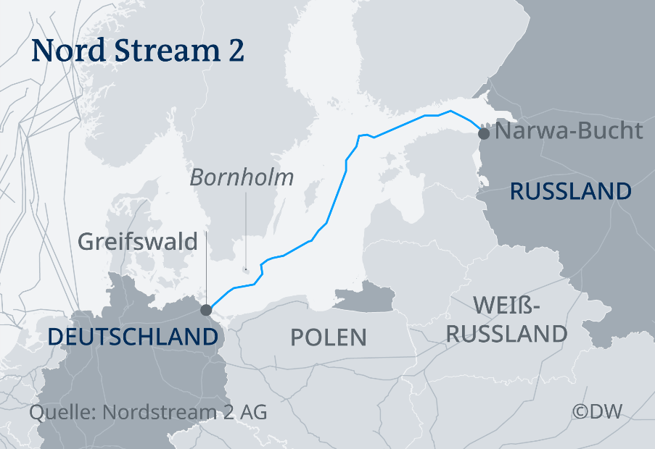

Die Bundesregierung reagierte verärgert. Der Staatsminister im Auswärtigen Amt, Niels Annen (SPD), sagte dem "Handelsblatt", die US-Politik der extraterritorialen Sanktionen gegen enge Partner und Verbündete sei ein schwerwiegender Eingriff in "unsere nationale Souveränität".

Deutsche Welle
Warnungen vor Scheitern von Nord Stream 2
https://www.dw.com/de/warnungen-vor-scheitern-von-nord-stream-2/a-54526747

Der deutsche Außenminister Heiko Maas sagte am Dienstag in Moskau zu der Nord Stream-Frage: "Kein Staat hat das Recht, der EU ihre Energiepolitik zu diktieren. Und das wird auch nicht gelingen." Maas hatte zuvor mit seinem russischen Kollegen Sergej Lawrow gesprochen. "Sanktionen zwischen Partnern (sind) definitiv der falsche Weg", fügte er mit Blick auf die US-Drohungen hinzu. Er habe diese Position am Wochenende auch US-Außenminister Mike Pompeo erklärt.

Financial Times
Poland fines Gazprom €50m over Nord Stream 2 pipeline
https://www.ft.com/content/42d196cf-0622-4255-8cab-98a2de961f73

Poland has fined Russia’s state-controlled gas giant Gazprom 213m zloty (€50m) for its lack of co-operation with an investigation by Warsaw’s anti-monopoly watchdog into the Nord Stream 2 pipeline.

The Kremlin-controlled gas company responded by saying that the information request was invalid and that it would not pay the fine pending a potential appeal.

Despite the mounting pressure, the pipeline is edging closer to completion, with only 160km of underwater infrastructure left to connect it to the receiving station in northern Germany.

Last month, Denmark’s energy agency gave Gazprom permission to resume work on the pipeline, the last stretch of which lies within Danish waters. Analysts estimate that the final section could be laid in about 3 months.
Nord Stream 2 진행 회사
Gazprom: https://www.gazprom.com/
Nord Stream 2: https://www.nord-stream2.com/

