The White House
Office of the Press Secretary
For Immediate Release
May 12, 2016
https://www.whitehouse.gov/the-press-office/2016/05/12/press-briefing-press-secretary-josh-earnest-5122016

Press Briefing by Press Secretary Josh Earnest, 5/12/2016
James S. Brady Press Briefing Room

Q I appreciate that. But can you give us a little bit more there? I mean, there was this pretty overt action, this maritime operation near that Chinese-occupied reef in the South China Sea. The U.S. and Australia coming quite close with warships. I mean, that's happening. The President is headed to Asia next week. The steel glut was named in that readout. Obviously, China is the one who's been getting a lot of blame for overproduction there. Would you say that tensions are on the rise with China?
MR. EARNEST: I would not describe it that way. Our concerns about China's activities in the South China Sea are well-documented, and our concerns are concerns that we have raised both publicly and privately with Chinese officials at a range of levels. The freedom of navigation operation that was carried out by U.S. forces earlier this week is relatively routine. We've done at least a couple of times just in the last four or five months. And it is not intended to be a provocative act. It merely is a demonstration of a principle that the President has laid out on a number of occasions, which is that the United States will fly, operate and sail anywhere that international law allows. And this operation was undertaken consistent with that principle.
And the concerns and the tensions that exist around the South China Sea don't actually directly involve the United States. The United States is not a claimant to any of the land features in the South China Sea. Our concern lies principally with the need for those parties that do have competing claims to resolve them through diplomacy. And we certainly do not want to see the tensions increase because of the risk that that could pose to the extensive international commerce that's conducted in that region of the world.
So I think this also underscores the complexity of the U.S. relationship with Australia. Australia is one of our closest allies, and we work with them on a range of issues. And I'll let the Australians describe the concerns that they may have, or the impact on their national security that tensions in the South China Sea may have. But obviously the Australian economy is affected by the glut of capacity in the steel industry in much the same way that the U.S. is, as well. I know that Prime Minister Turnbull has indicated his own priority for ensuring the international trade is conducted fairly. And that common ground is the basis for the kinds of conversations that President Obama and he have on a fairly regular basis.
So these are -- I think at the same time, the thing that sort of underlies all of this is we have been able to work with China in pursuit of other priorities. And we've talked about North Korea and the influence that the Chinese government has with North Korea. The sanctions that were imposed by the United Nations against North Korea that went further than any set of previous sanctions that have been imposed on them were only possible because the United States and China were able to cooperate in implementing them. Obviously, we've worked with China to complete the Iran deal that we discussed earlier. That would not have been possible without China's active participation in the discussions, but also, China had to be helpful in terms of imposing and enforcing the sanctions that compelled Iran to the negotiating table in the first place.
So I think this illustrates that there are differences of opinion that we have with China, and I’m certainly not seeking to downplay them. They’re significant, and they have significant consequences for our economy in particular.
But they have not prevented the United States and China from being able to work effectively together to pursue other areas where we’re in better agreement.
Q But why go out of your way to not name China? I mean, that’s obviously who you were talking about. And then that’s where the point of tension is. I mean, if you’re having a destroyer go near a reef you’re concerned are going to turn into an airstrip to land jets on, and that’s a U.S. destroyer, I mean, that’s a pretty overt signal. But you don’t want to say China directly. I mean, it seems like an effort, a very concerted effort to avoid appearing to look confrontational.
MR. EARNEST: Well, I think we’re not just trying to avoid appearing confrontational. I think I said in my previous answer that we certainly did not intend for that to be considered a provocative act. So I think we’re being pretty explicit about that. And we’ve been explicit about that fact, both in public and in private, at a range of levels. And so --
MR. EARNEST: Well, we know that Vietnam in particular has some concerns about competing claims in the South China Sea. We know that Vietnam is a signatory to the Trans-Pacific Partnership, and we certainly are looking to broaden our economic relationship with Vietnam. There’s a rapidly growing middle class in Vietnam, and U.S. companies could benefit from the opportunity to do business in that part of the world. That would be good for the U.S. economy, it certainly would be good for U.S. workers, and the President is committed to pursuing that priority as he travels overseas.
And look, we know that China sees the same potential benefit if they can increase their ability to do business inside of Vietnam. That’s actually the essence of the argument that the President has made with regard to the Trans-Pacific Partnership -- that if the United States and the rest of the international community doesn’t go in and write the rules of the road for doing business in Vietnam, then China will. And the benefits of the United States being a part of those rules of road, it means we’re going to have high labor standards, we’re going to have higher human rights standards, higher environmental standards.
China hasn’t made those things a priority, and we know that if China is given an opportunity to get a foothold in Vietnam, they certainly are not going to be interested in raising standards. You could even imagine a scenario where they might even allow those standards to be lowered even further.
So there’s no denying that at least when it comes to our relationship with Vietnam, there are significant consequences for our relationship with China. But we never want to create a scenario in which we can’t pursue our common interests with China, and the President has been quite clear about that. And we’ve been effective in implementing that strategy in a way that has had positive benefits for China and the United States. And, in fact, that’s why the other thing that we often say in describing our relationship with China is that we welcome a rising China. In fact, that’s the reason that we’re hopeful that they can be persuaded to abide by the international rules of the road when it comes to resolving competing claims in the South China Sea.
When you’re an economy as large as China, when you’re as influential as China is, particularly in that region of the world, then you benefit from the ability of disputes to be resolved without going to war, and you benefit from disputes being resolved with the expectation that everybody is going to follow the rules. And that’s certainly the case that we make to China, and I think that’s an indication of how we’re able to work with China, how we welcome a rising China. But look, we’re going to have our differences and we’re not going to shy away from expressing those.

ANNUAL REPORT
TO CONGRESS
Military and Security Developments
Involving the People’s Republic of China 2016
Office of the Secretary of Defense
http://www.defense.gov/Portals/1/Documents/pubs/2016%20China%20Military%20Power%20Report.pdf

DEVELOPMENTS IN CHINA’S TERRITORIAL DISPUTES

While China has resolved several land and maritime border disputes in the past, several persist—particularly the ongoing territorial and maritime disputes in the East China Sea, South China Sea, and along the China-India border. For the United States, some of these disputes involve U.S. allies with whom there exist long-standing cooperation and security treaty commitments. China’s actions in the South China Sea in 2015, particularly its land reclamation on features in the Spratly Islands, enhanced the appearance of China’s ability to exercise control over disputed areas in the South China Sea, raised tensions in the South China Sea, and caused concern over China’s long-term intentions.

South China Sea. China depicts its South China Sea claims by using a “nine-dash line” that encompasses most of the area. China remains ambiguous about the precise coordinates, meaning, or legal basis of the nine-dash line. Brunei, Malaysia, the Philippines, Taiwan, Indonesia, and Vietnam all contest portions of China’s territorial and maritime claims in the South China Sea.

In 2015, China accelerated land reclamation and infrastructure construction at its outposts in the Spratly Islands. When complete, these outposts will include harbors, communications and surveillance systems, logistics facilities, and three airfields. Although artificial islands do not provide China with any additional territorial or maritime rights within the South China Sea, China will be able to use its reclaimed features as persistent civil- military bases to enhance its presence in the South China Sea significantly and enhance China’s ability to control the features and nearby maritime space.

Throughout 2015, Chinese Coast Guard (CCG) ships maintained a presence at Scarborough Reef, continuing operations that began in 2012. Chinese officials asserted in 2015 that the patrols were normal and justifiable, claiming that China has indisputable sovereignty over the various features in the South China Sea and adjacent waters. Both China and the Philippines continue to claim sovereignty over Scarborough Reef and Second Thomas Shoal. China maintains a continuous CCG presence at both locations while the Philippines stations military personnel aboard a tank landing ship that has been grounded on Second Thomas Shoal since 1999.

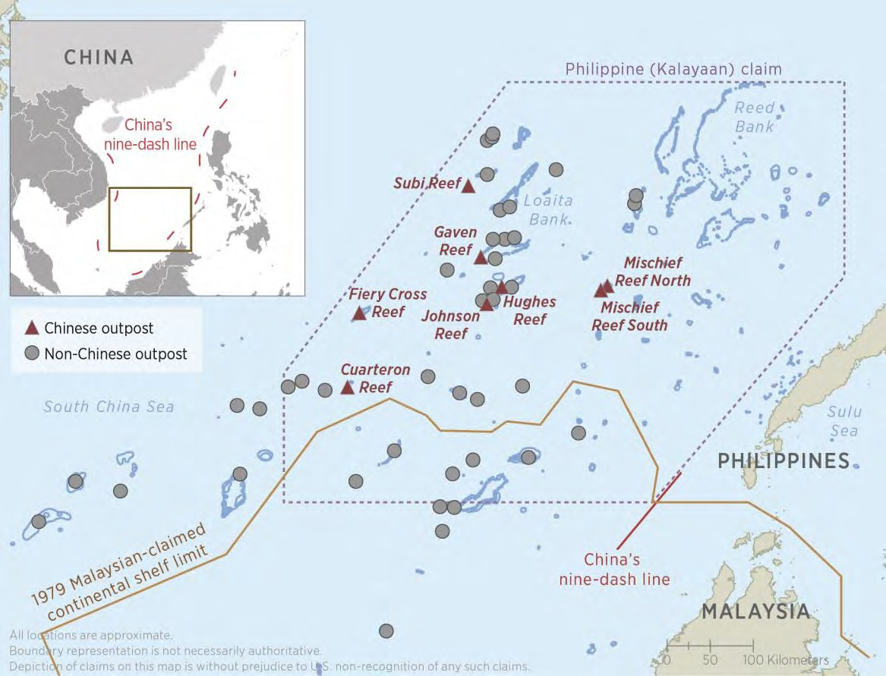
In October 2015, an arbitral tribunal constituted at the request of the Philippines and pursuant to Chapter XV of the Law of the Sea Convention ruled that it has jurisdiction to decide certain disputed issues between the Philippines and China, such as whether a particular feature is an “island” entitled to a territorial sea, an exclusive economic zone, and continental shelf; a “rock,” a subset of islands that are entitled only to a territorial sea; or a feature that is submerged at high tide and thus not entitled to any maritime zone of its own. The arbitral tribunal will not rule on sovereignty claims to land features. The tribunal is expected to issue a ruling on the merits of the case in 2016. China continues to reiterate that it does not accept the jurisdiction of the arbitral tribunal and will not abide by its decision.

Other disputed areas include the Luconia Shoals, Reed Bank, and the Paracel Islands. The Luconia Shoals are disputed by China and Malaysia and may contain extensive oil and natural gas reserves, as well as productive fishing grounds. Reed Bank is claimed by both China and the Philippines, and in August 2014, China sent hydrographic research vessels to survey the area. In disputed waters near the Paracel Islands, tensions between China and Vietnam spiked in 2014 when China deployed and commenced operation of a state-owned exploratory hydrocarbon rig in waters also claimed by Vietnam.

CHINA’S USE OF LOW-INTENSITY COERCION IN MARITIME DISPUTES

China has used low-intensity coercion to enhance its presence and control in disputed areas of the East and South China Sea. During periods of tension, official statements and state media seek to frame China as reacting to threats to its national sovereignty or to provocations by outside actors. China often uses a progression of small, incremental steps to increase its effective control over disputed areas and avoid escalation to military conflict. China has also used punitive trade policies as instruments of coercion during past tensions and could do so in future disputes. In 2015, China continued to employ Chinese Coast Guard and PLA Navy ships to implement its claims by maintaining a near-continuous presence in disputed areas in order to demonstrate continuous and effective administration. Recent land reclamation activity has little legal effect, but will support China’s ability to sustain longer patrols in the South China Sea. In 2012, China restricted Philippine fruit imports during the height of Scarborough Reef tensions. In 2010, China used its dominance in the rare earth industry as a diplomatic tool by restricting exports of rare earth minerals to Japan amid tensions over a collision between a Chinese fishing boat and Japanese patrol ship.

RECLAMATION AND CONSTRUCTION IN THE SOUTH CHINA SEA

China paused its two-year land reclamation effort in the Spratly Islands in late 2015 after adding over 3,200 acres of land to the seven features it occupies; other claimants reclaimed approximately 50 acres of land over the same period. As part of this effort, China excavated deep channels to improve access to its outposts, created artificial harbors, dredged natural harbors, and constructed new berthing areas to allow access for larger ships. Development of the initial four features—all of which were reclaimed in 2014—has progressed to the final stages of primary infrastructure construction, and includes communication and surveillance systems, as well as logistical support facilities.

At the three features where the largest outposts are located, China completed major land reclamation efforts in early October 2015 and began transitioning to infrastructure development, with each feature having an airfield—each with approximately 9,800 foot-long runways—and large ports in various stages of construction. Additional substantial infrastructure, including communications and surveillance systems, is expected to be built on these features in the coming year.

China’s Government has stated these projects are mainly for improving the living and working conditions of those stationed on the outposts, safety of navigation, and research. However, most analysts outside China believe that China is attempting to bolster its de facto control by improving its military and civilian infrastructure in the South China Sea. The airfields, berthing areas, and resupply facilities will allow China to maintain a more flexible and persistent coast guard and military presence in the area. This would improve China’s ability to detect and challenge activities by rival claimants or third parties, widen the range of capabilities available to China, and reduce the time required to deploy them.

