김원정
November 28, 2017
Writer - Elsa B. Kania
Address - https://www.cnas.org/publications/reports/battlefield-singularity-artificial-intelligence-military-revolution-and-chinas-future-military-power
Battlefield Singularity: Artificial Intelligence, Military Revolution, and China’s Future Military Power
(approximately 70 pages - report)
The Chinese leadership is advancing an “innovation-driven” strategy for civilian and military development, aiming to become the world’s “premier innovation center” in AI by 2030.
…omitted...
The intersection of the PLA’s focus on scientific approaches to warfare with the preference to consolidate and centralize decision-making could also cause the PLA’s leadership to rely more upon AI, rather than human judgment.
…omitted...
The PLA is also funding research on concepts of humanmachine integration or “fusion” (人机融合) and human-machine coordination (人机协同).

December 04, 2017
Writer - C. Raja Mohan
Address - http://carnegieindia.org/2017/12/05/raja-mandala-after-indo-pacific-eurasian-idea-pub-74904
After Indo-Pacific, the Eurasian Idea
(article)
If Indo-Pacific is an idea that gained traction during 2017, Delhi must now cope with another expansive geopolitical construct — Eurasia. The Indian political and policy establishment, long brought up on the notion that Europe and Asia are different, must adapt to their slow but certain integration into a single geopolitical theatre.
The Chabahar port on the south-eastern coast of Iran, formally launched on Sunday by President Hassan Rouhani, opens up not just an alternative route to Afghanistan but also facilitates India’s overland connectivity with Central Eurasia.
Like the Indo-Pacific, the concept of Eurasia is quite familiar to geographers. Marine bio-geographers use the Indo-Pacific to describe the large stretch of tropical waters from the east coast of Africa to the Western Pacific that has many common features. For geologists, Eurasia refers to a tectonic plate that lies under much of what we know as Europe and Asia. But it is in the domain of politics that the terms Indo-Pacific and Eurasia acquire a baggage all of their own. Recall the resistance in Delhi to the idea of the Indo-Pacific. Although Prime Minister Manmohan Singh occasionally used the term, there was considerable scepticism within the South Block. For many, the Indo-Pacific was a suspicious American invention.
…omitted...
But it was really Japan’s Shinzo Abe who imagined the Indo-Pacific. Australia was quick to adopt it. Jakarta, which along with Delhi dreamt of Asian unity and founded the non-aligned movement in the middle of the last century, was enthusiastic in its embrace of the Indo-Pacific.
…omitted...
There is indeed a Eurasia Division in India’s ministry of external affairs that deals with a significant part of the post-Soviet space. That is quite close to the most common usage of the term. In Russia, the Eurasian idea has a special resonance. Eurasia is supposed to represent a unique cultural, spiritual and geographic space that is neither east nor west. For many in Russia, Eurasia invokes either the memories of the vast Russian empire or rekindles nostalgia for the Soviet Union.
…omitted...
What is new to the debate, though, is China. Much in the manner that the rise of China is connecting up the Pacific and Indian Oceans, Beijing is breaking down the idea that Europe and Asia are two different continents. More immediately, it is about the expanding Chinese economic and political influence in spaces that were once dominated by either the West or Russia.
…omitted...
The problem for India is two fold. Delhi’s world-view, traditionally defined in terms of an irreconcilable tension between “East and West”, “North and South” or “Europe and Asia” is becoming unsustainable as China’s massive Silk Road Initiative begins to integrate Europe with Asia. The old metrics of foreign policy purity in Delhi — distance from the West and solidarity with the East — make no sense as Chinese expansion and American retrenchment reshape the political and economic geography of Eurasia.
…omitted...
Prime Minister Narendra Modi has put India back in play in the maritime world by accepting the Indo-Pacific idea. But Delhi is yet to come to grips with continental Eurasia. If the Great Himalayan barrier and post-Partition geography have made it hard for India to develop connectivity with inner Asia, Delhi has been reluctant to walk though the open door in Europe. Focused as it is on bilateral relations with France, Germany and Russia, Delhi has neglected the European Union and ignored Central Europe. Correcting this imbalance is the first step towards a more purposeful Indian engagement with Eurasia.

November 23, 2017
Writer - Derek Grossman
Address - https://www.rand.org/blog/2017/11/us-striking-just-the-right-balance-with-vietnam-in.html
U.S. Striking Just the Right Balance with Vietnam in South China Sea
(Comment)
…omitted…
Finally, while attending the Asia-Pacific Economic Cooperation conference in Da Nang the day before, on November 10, Trump referred to the region multiple times as the “Indo-Pacific.” Even though this term was originally coined in 2007 to describe the growing interconnectivity between the Indian Ocean and Asia-Pacific regions, it has since evolved to imply to many observers an effort by the United States to leverage its superior naval capabilities to contain China in both regions. Indeed, Trump played into this conception of the Indo-Pacific by reviving quadrilateral talks — comprised of the United States, Australia, Japan, and India — during his Asia visit.
…omitted…
Vietnam is particularly wary of a repeat scenario. Vietnam instead prefers stable U.S.-China ties to preserve its non-aligned yet “multidirectional” cooperative approach
…omitted…
Trump's deepening defense engagement with Vietnam is a positive development for the United States as well. Washington has an acute interest in freedom of the seas to safeguard the global economy. Chinese domination of the South China Sea runs contrary to that objective, and support to Vietnam will complicate Beijing's ability to bully its way to victory.

November 30, 2017
Writer - Eleanor Albert
Address - https://www.cfr.org/backgrounder/north-koreas-military-capabilities
North Korea’s Military Capabilities
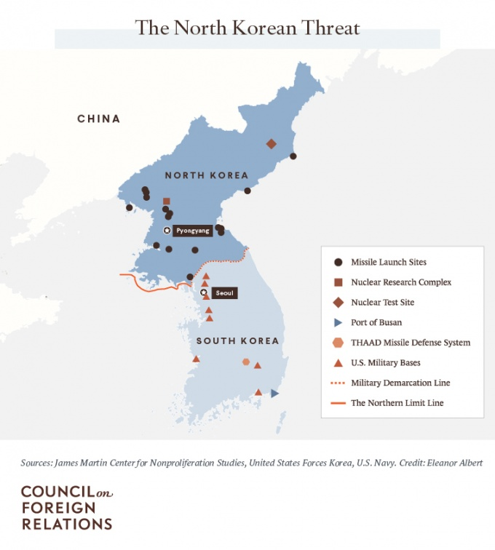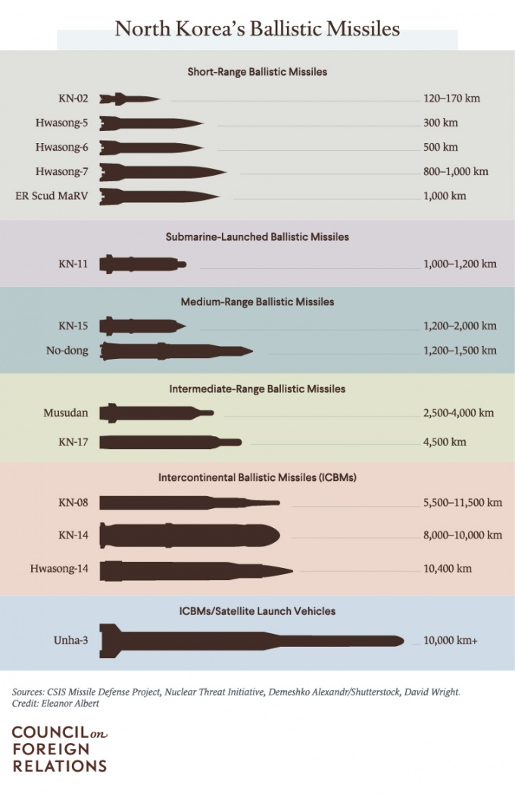
North Korea has embarked on an accelerated buildup of weapons of mass destruction and modernization of its already large conventional force
Pyongyang said that in its November testing of the new Hwasong-15 ICBM, the missile hit an altitude of 4,475 kilometers (2,780 miles), far above the International Space Station, and flew about 1,000 kilometers (590 miles) before landing in the sea off Japan’s coast. Analysts estimate the Hwasong-15 has a potential range of 13,000 kilometers (8,100 miles) and, if fired on a flatter trajectory, could reach anywhere on the U.S. mainland.
…omitted…
American analysts and experts from other countries still debate the nuclear payload that the ICBM could carry, and it is still unclear whether the ICBMs have the capability to survive reentry.
…omitted…
The North is believed to have an arsenal of chemical weapons, including sulfur mustard, chlorine, phosgene, sarin, and VX nerve agents.
…omitted...
In recent years, responsibility for cyberattacks on South Korean banks and media outlets as well as the 2014 Sony Pictures hack was attributed to groups with ties to North Korea.
…omitted…
Pyongyang and government-linked cyber entities view cyberattacks as a means of seeking financial gain, acting as a deterrent against adversaries in the event of military conflict, and fulfilling the country’s desire of being portrayed as a capable and dangerous actor, says Adam Segal, director of CFR’s Digital and Cyberspace Policy Program.

Kim Jong-un believes that nuclear weapons are his guarantee of regime survival. ”
- Bruce Bennett, RAND Corporation

