economics

Alarm Sounds for World Growth as Bellwether Economy Contracts

South Korea, a bellwether for global trade and technology, cast doubt over hopes for a quick rebound in the world economy by reporting its biggest contraction of gross domestic product in a decade.
Asia’s fourth-largest economy shrank by 0.3 percent in the first quarter from the previous three months, versus estimates for a 0.3 percent gain. That’s a big worry for other manufacturing and technology-driven exporters, including Japan, Germany and Taiwan. A separate report showed global trade volumes are falling at the fastest pace in a decade.

Getting Worse
Global trade volumes are falling at the fastest pace in a decade
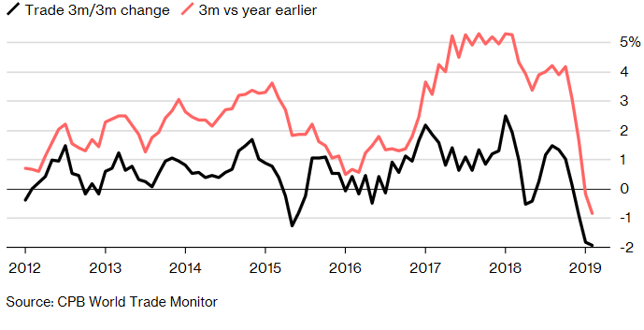

Hot on the heels of the surprise reading from Korea, the Bank of Japan warned of “high uncertainties” in its outlook for growth as it pledged to keep interest rates at rock bottom levels through at least spring of 2020. The BOJ now projects that it won’t hit its 2 percent inflation target at least through March 2022, which will be nine years since Governor Haruhiko Kuroda launched his radical program to reflate prices.
Click here to read more on the BOJ and ultra-low interest rates
“If you look at investment in the electronic- and trade-dependent economies of our region -- Singapore, Malaysia, Thailand, Taiwan, now Korea -- capex is falling, capex is weak,” said Shaun Roache, Asia-Pacific chief economist in Singapore at S&P Global Ratings. “That’s an important signal. It’s hard at this stage to know whether that’s just a cyclical downturn or there’s something more dangerous going on that’s related to trade tension. That’s going to be something to watch.”
While China’s stabilizing economy has been expected to lift the rest of Asia, and the world, the problems faced by Korea suggest that the hurdles to a quick rebound remain high. Meanwhile, the BOJ’s struggle to spur prices is a worrying sign for some of its global peers, who are struggling with their own stubbornly low inflation and face talk of “Japanification.”
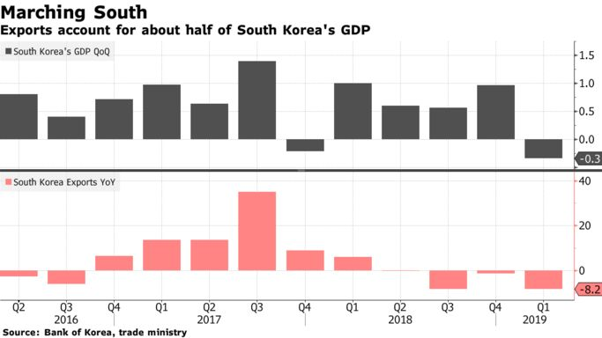
Exports account for about half of Korean GDP and are on course for a fifth-straight monthly decline. Slowing sales to China -- Korea’s biggest market -- and soft demand for semiconductors are biting, hurting corporate giants like Samsung Electronics Co. and SK Hynix Inc.
The Bank of Korea last week reduced its 2019 growth forecast to 2.5 percent while the government has announced a supplementary spending package of 6.7 trillion won ($5.9 billion), which it says may push up GDP by 0.1 percentage point and create at least 73,000 new jobs.
For now, there are few signs of a major uptick in global exports. The International Monetary Fund cut its forecast for global expansion to the slowest pace since the financial crisis a decade ago. In Europe, recent signals have been mixed, with manufacturing remaining the big drag on economy. U.S. gross domestic product due Friday is expected to show the economy expanded by 2.2 percent.

Tech Pain
While policy makers in Seoul are hoping the tech cycle will bottom, Korea’s reliance on memory chips is backfiring. Hynix, a supplier to Apple Inc., posted its worst drop in operating profit since 2012 on Thursday as memory-chip prices continue their free fall amid weakening demand from smartphone makers and data centers. Earlier in April, Samsung Electronics reported its worst operating-profit drop in more than four years.
The worse-than-expected GDP data, coupled with inflation that’s well below its 2 percent target, ought to encourage the Bank of Korea to respond with lower interest rates, said Rob Carnell, Asia-Pacific head of research and chief economist at ING Bank in Singapore. The benchmark rate has been unchanged at 1.75 percent since November last year.

What Bloomberg’s Economists Say
“Fiscal support may need to be stepped up. The recently proposed extra budget, which we previously estimated would offset the drags from investment and exports, is unlikely to be sufficient to support growth. ... The Bank of Korea may also need to place greater attention on supporting growth.”
--Justin Jimenez, economist
Click here to view Korea Insight
From a year earlier, the Korean economy expanded 1.8 percent, compared with projections of 2.4 percent. Facilities investment fell 11 percent in the first quarter from the previous three months, the biggest drop in 21 years. Construction investment declined 0.1 percent from the earlier period, when it gained 1.2 percent.
GDP export volumes fell 2.6 percent from the previous three months, import volumes fell 3.3 percent, government spending rose 0.3 percent, and private spending gained 0.1 percent.
Finance Minister Hong Nam-ki said the economy would improve in the second quarter, and that the second half of the year would be better than the first as the government focuses on building up economic momentum.
It’s a view that at least some economists also share.
“I would not jump to a bearish conclusion before seeing second-quarter numbers,” said Kathleen Oh, economist at Bank of America Merrill Lynch in Hong Kong.
— With assistance by Peter Elstrom, Malcolm Scott, Heejin Kim, Hooyeon Kim, Fergal O'Brien, and Kevin Hamlin

economics

How Economists Are Reacting to South Korea's Unexpected GDP Contraction

Here is a selection of comments from economists following Bank of Korea’s report that South Korea’s first-quarter gross domestic product shrank the most in a decade.
For a full account of the first-quarter GDP report, click here
Kong Dongrak, Daishin Securities in Seoul:
“We are considering bringing forward our BOK rate cut call, which currently forecasts the central bank to cut rates sometime in the fourth quarter. I assume many other economists, who have maintained a rate hold view, will probably change their call following today’s reading.”
“Yields of three-year bonds may drop to as low as 1.7 percent in the next month, while 10-year yields could dip to 1.85 percent.”
Park Chong-hoon, Standard Chartered Bank in Seoul:
“It was a surprise. The growth figures were extremely bad. In order to meet the BOK’s growth forecast of 2.3 percent for the first half, the economy should expand at least 1.5 percent in the second quarter, which looks daunting.”
“The latest figure shows that the business sentiment is clearly bad. Facilities investment equals business sentiment but this seems extremely squeezed; so that worries me. The latest growth figure will likely make people think the government may have become too complacent over economic issues.”
Rob Carnell, ING Bank in Singapore:
“The numbers were bad, worse than expected, and coupled with low inflation, ought to encourage the BOK to respond with easier policy rates.”
“At the heart of this is the global semiconductor slump, which is weighing on both exports and investment, but also feeding through into generally weak domestic demand and sentiment.”
“Government measures to provide offsetting stimulus look insufficient to totally offset these drags, and further weakness of both activity and inflation in the coming months and quarters look likely.”
Kim Doo-un, KB Securities in Seoul:
“As was expected the capital investment seemed very bad. It will only start improving from the latter half of the year. Looking at those figures, I may have to revise down my previous growth forecast of 2.5 percent for this year.”
“The latest reading shows the overall investment, including facilities and construction, is completely stalled and it will take some time to get these back on track.”
“Any sharp improvement in investment is unlikely at least until the second quarter of this year. But it may improve slightly in the second half, partly helped by lower base effect last year

