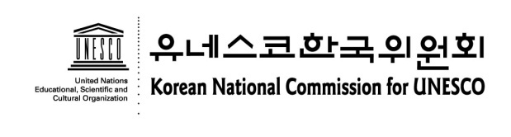
2nd International Youth Forum on
Historical Reconciliation in East Asia
19-23 August 2013 / Seoul, Republic of Korea
APPLICATION FORM

The Application Form for the International Youth Forum must be typed in English or Korean, and submitted no later than 12 July 2013. If you need more space for your Profile, you may add one more page and attach it with a paper clip.

1. Personal Information
Family Name (Last Name) | First Name (Given Name) | Please attach your photo here.
Gender (F / M) | Date of Birth (dd/mm/yyyy)
Occupation (Name of School /Organization)

English speaking skill : High / Medium/ Low
Other Languages :

2. Contact Information
Address
Telephone # (incl. country/area code) | Fax # (incl. country/area code)
E-mail 1.
2.

3. Profile
⑴ Please briefly describe your educational/academic background. (150 word limit)

(2) Please give a detailed description of any academic or work experience that may be relevant to the theme of the forum. (300 word limit)

(3) What role(s) do you think youth can play for historical reconciliation in East Asia? (500 word limit / This question will be weighed significantly in our selection of the participants)

(4) Please add any other information that you feel is relevant including special dietary.

I hereby certify that all of the information given is accurate.

Signature of Applicant:
Date:

Contacts
Mr. Seong-wook Hong , Youth Team, Korean National Commission for UNESCO
Address: 26 Myeongdong-Gil, Jung-Gu, Seoul 100-810, Korea
Tel: +82-2-6958-4158 / Fax: +82-2-6958-4253 / E-mail: youthforum@unesco.or.kr

