- 아포스티유 확인 제도(Apostille)

- 명칭: 외국공문서에 대한 인증의 요구를 폐지하는 협약
Title: Abolishing the certification process for foreign official documents
- 개요: 협약 가입국들 사이에서 공문서의 국제적 활용을 보다 용이하게 하기
위해, 외국 공관의 영사확인 등 복잡한 인증절차를 폐지하는 대신 공문서
발행국가가 인증하는 내용을 골자로 하는 다자간 협약
Summary: Instead of abolishing complicated certification process for international use of official documents among member countries, Apostille is a multilateral agreement making the certified contents of the issuing countries as the gists

- 가입국 현황: 미국, 영국, 프랑스, 독일, 일본, 중국(홍콩, 마카오만 적용) 등
99개국 (2010. 11월 현재)
Members of Agreement: US, UK, France, Germany, Japan, China(only Hong Kong, and Macao), and 99 other countries (as of November, 2010)
- 우리나라에 대한 발효: 2007.7.14
Effective Date for Korea: 2007. 7. 14

- 아포스티유 확인 대상 문서(Documents allowed for Apostille Certification)

1. 정부기관(지방자치단체, 교육기관)
Issued by Government Organization (Local Government, Educational Organization)
2. 공증인의 자격을 가진자 가 작성한 공증문서
Official Document written by a person with notary authority

- 정부기관 발행문서: 호적등본, 납세사실 등
증명서, 이혼판결문, 의약품 허가 확인서, 국공립학교발행 성적증명서 Document issued by Government Organization: copy of family register, tax payment certificate, divorced sentencing, pharmaceuticals permission certificate, academic record issued by national·public schools
- 공증이 필요한 문서: 회사발행 문서, 진단서(국공립병원 발행문서는 정부 발행문서에 해당), 사립학교 발행 성적증명서·졸업 중명서 등 정부기관 발행문서가 아닌 문서
Documents that need notary: documents issued by firm, medical certificate(national·public hospital issued documents are included in Government Org. issued documents), academic record·diploma issued by private school, etc. (other documents not issued by Government Organization)

- How to Issue Apostille

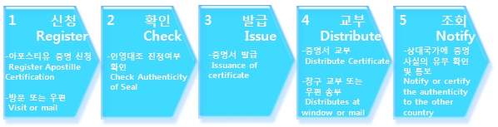

- 아포스티유 발급 수수료(Fee for Apostille)
매 1건당 1,000원(영사확인의 경우, 건당 500원임)
\1,000 for one (\500 in case of consul confirmation)

- Where to issue Apostille
- 외교통상부 별관 1 영사민원실 (코리안 리 빌딩 4층)
4th floor of Korean Reinsurance Company
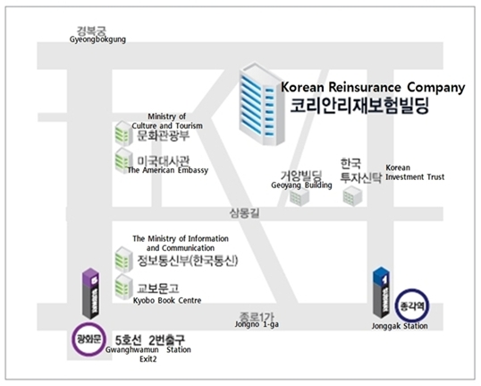
- 우편 발급 방법(How to send mail):
신청서류 일체, 반송용 우표 및 봉투, 수수료를 ‘서울특별시 종로구 수송동80 외교통상부
별관 Ⅰ Korean Re 빌딩4층 영사민원실 아포스티유 담당자’에게 송부
문의전화: 02)2100-7600
Send all of the documents, stamp, envelope for returning, fee to ‘Seou-si Jongno-gu Susong-dong80, Annex(별관) Ⅰ of the Ministry of Foreign Affairs and Trade, 4th floor of Korean Re building consul public service center(영사민원실), Person in charge of Apostille
Contact Number: 02)2100-7600
- 아포스티유 신청 구비서류(Required documents for Apostille)
- 아포스티유 발급신청서
Application for Apostille issuance
- 아포스티유 확인을 받고자 하는 공문서 또는 공증된 문서
Official document or authentic documents that needs to be certified as Apostille
- 대리인에 의한 신청인 경우 대리인의 신분증 사본
In case of applying by the substitute, the substitute person must bring copy of ID card
- 외무부 장관이 행하는 영사관계 문서의 확인 사무 수수료규칙에 의한 수수료
fee for the Foreign Minister regulation
※ 신청인이 문서를 제출할 국가에서 번역문을 필요로 하는지 필요하다면 어떤 절차를 거쳐야 하는지 정확하게 파악하여 대처하여야 불편이 예방된다고 하겠습니다
The translation document depends on which country the individual is going to submit to. Therefore, the individual needs to be sure of what procedure needs to be taken if translation is required

- 아포스티유 협약 가입국(Member Nations of Apostille)

국가, 발효일, 발급기관 수
Albania 2004-5-9 1 | Mexico 1995-8-14 1
Argentina 1988-2-18 1 | Monaco 2002-12-31 1
Australia 1995-3-16 1 | Montenegro 2006-6-3 1
Austria 1968-1-13 1 | Netherlands 1965-10-8 1
Belarus 1992-5-31 1 | New Zealand 2001-11-22 1
Belgium 1976-2-9 1 | Norway 1983-7-29 1
Bosnia and Herzegovina 1965-1-24 1 | Panama 1991-8-4 1
Bulgaria 2001-4-29 1 | Peru 2010-9-30 1
China, People’s Republic of 2 | Poland 2005-8-14 1
Croatia 1965-1-24 1 | Portugal 1969-2-4 1
Cyprus 1973-4-30 1 | Romania 2001-3-16 1
Czech Republic 1999-3-16 1 | Russian Federation 1992-5-31 1
Denmark 2006-12-29 1 | Serbia 1965-1-24 1
Ecuador 2005-4-2 1 | Slovakia 2002-2-18 1
Estonia 2001-9-30 1 | Slovenia 1965-1-24 1
Finland 1985-8-26 1 | South Africa 1995-4-30 1
France 1965-1-24 1 | Spain 1978-9-25 1
Georgia 2007-5-14 1 | Suriname 1975-11-25 1
Germany 1966-2-13 1 | Sweden 1999-5-1 1
Greece 1985-5-18 1 | Switzerland 1973-3-11 1
Hungary 1973-1-18 1 | The former Yugoslav Republic of
Iceland 2004-11-27 1 | Macedonia 1965-1-24 1
India 2005-7-14 1 | Turkey 1985-9-29 1
Ireland 1999-3-9 1 | Ukraine 2003-12-22 1
Israel 1978-8-14 1 | United Kingdom of Great Britain and
Italy 1978-2-11 1 | Northern Ireland 1965-1-24 1
Japan 1970-7-27 1 | United States of America 1981-10-15 1
Korea, Republic of 2007-7-14 1 | Venezuela 1999-3-16 1
Latvia 1996-1-30 1 | Andorra 1996-12-31 1
Lithuania 1997-7-19 1 | Antigua and Barbuda 1981-11-1 1
Luxembourg 1979-6-3 1 | Armenia 1994-8-14 1
Malta 1968-3-3 1 | Azerbaijan 2005-3-2 1
Brunei Darussalam 1987-12-3 1 | Bahamas 1973-7-10 1
Cape Verde 2010-2-13 1 | Barbados 1966-11-30 1
Colombia 2001-1-30 1 | Belize 1993-4-11 1
Cook Islands 2005-4-30 1 | Botswana 1966-9-30 1
Dominica 1978-11-3 1 | Malawi 1967-12-2 1
Dominican Republic 2009-8-30 1 | Marshall Islands 1992-8-14 1
El Salvador 1996-5-31 1 | Mauritius 1968-3-12 1
Fiji 1970-10-10 1 | Moldova, Republic of 2007-3-16 1
Grenada 1974-2-7 1 | Mongolia 2009-12-31 1
Honduras 2004-9-30 1 | Namibia 2001-1-30 1
Kazakhstan 2001-1-30 1 | Niue 1999-3-2 1
Kyrgyzstan 2011-7-31 1 | Saint Kitts and Nevis 1994-12-14 1
Lesotho 1966-10-4 1 | Saint Lucia 2002-7-31 1
Liberia 1996-2-8 1 | Saint Vincent and the Grenadines 1979-10-27 1
Liechtenstein 1972-9-17 1 | Swaziland 1968-9-6 1
San Marino 1995-2-13 1 | Tonga 1970-6-4 1
Sao Tome and Principe 2008-9-13 1 | Trinidad and Tobago 2000-7-14 1
Seychelles 1979-3-31 1 | Vanuatu 1980-7-30 1

※ Detail information may be found at www.0404.go.kr or call Apostille confirmation consul call center 2100-7600 or consul center 3210-0404

- Documents issued from Ajou University(including the possible issuing date)

-성적증명서 (Official Transcript of Academic Record): from Dec. 26
-졸업예정증명서 (‘To be graduated’ Certificate): Present~until Feb.23
-졸업증명서 (Graduation Certificate): from Feb. 22
-졸업장 (Diploma): from Feb. 22
※exceptionally, if one needs the diploma earlier due to returning date, one may get it from 4 days earlier from the graduation day. However, this person must notify Office of International Affairs in advance for official procedure.

