「(MERS)」
Prevention and Reporting Guidance
For Higher Education Institute

June 8th, 2015

- If any student suffers from fever during lecture or campus activities, check body temperature at the University infirmary.
- Check if you have coughing, runny nose, sore throat or breathing problem.
- If symptoms with temperature over 37.5℃, students should be instructed to return home. Those students should not visit any hospital, and should call to MERS HOT LINE 043-719-7777 and wait for medical assistance at home.
- After medical assistant visits, if those students need additional examination or need to be quarantined, students must stop coming to school immediately.
- Even after the test result is “negative”, those students must stop coming to school during the incubation period (14 days).
- Restrain from any student group activities.
- Restrain from field activities where high risk of contamination may arise
- MERS patients or MERS suspected patients should stop coming to school until the stated date on the “self-isolation notice”.

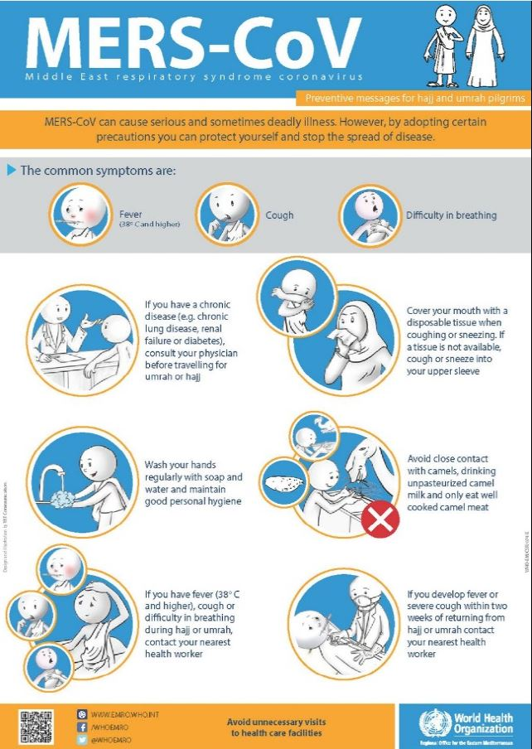

Guideline for MERS patients and families of MERS patients

[SELF ISOLATION Patients]
- Stay in separated area
- Frequent ventilation should be done, and stay at an independent space with individual sanitary facilities such as own bathroom and others.

- No contact or conversation with your family or housemates.
- In case of emergency, please wear masks and talk 2m apart.

- Using your own (towel, cutlery, mobile phone) sanitary stuffs.
- Wash clothes, beddings alone and do not share cutlery with others.

- Abide by health regulations
- Self hygiene must be kept. Wash your hands regularly and please use tissues when coughing.

- Check your condition for 14 days from the last day of your contact with the patient.
- Check for high temperature (over 37.5C), breathing problems (coughing etc), and digestive system problem (nausea, vomit, and diarrhea).

[Families of MERS patients]
- Avoid any contact with the patient, especially for elders and those with weak immune system.
- Check the health conditions of the patients carefully. Check for high temperature (over 37.5C), breathing problems (coughing etc.), and digestive system problem (nausea, vomit, and diarrhea).

Information of mers
[What is MERS?]
- Severe acute respiratory syndrome coronavirus which is originated by Middle East respiratory syndrome coronavirus(MERS-CoV)

[Outbreak Status]
- The first confirmed case was reported in Middle East area 2012. From April 2012 to 29 May 2015, there have been 1,167 cases of MERS reported in 25 countries with 479 deaths.
- Almost of all patients are related to Middle East area, especially Saudi Arabia, United Arab Emirates. It accounts for 97 percent (1,132) among the all sufferers.

[Illness characteristic]
- (incubation period) usually within 5 days, there are symptoms (min 2days ~ max 14 days)
- (symptoms) fever, cough, shortness of breath, and other respiratory symptoms
- (Treatment) proper internal treatment according to patients’ symptoms
- Up to now, there’s no vaccine and antiviral preparation to treat MERS
- (case fatality rate) 30% ~ 40%
- (infection process) exact infection route hasn’t been revealed
- some MERS patients have reported contact with camels in Saudi Arabia
- many people with MERS have had close contact with a person sick with MERS. (Mostly infection in hospital, infection among family)

MERS Q&A

- What is MERS?
Middle East Respiratory Syndrome (MERS) is an illness caused by a virus called Middle East Respiratory Syndrome Coronavirus (MERS-CoV). Most MERS patients developed severe acute respiratory illness with symptoms of fever, cough and shortness of breath. Some patients reported with MERS have died.

- What is the reason of MERS?
We don’t know for certain where the virus came from. However, it likely came from an animal source, in addition to humans, MERS-CoV has been found in bats and camels

- What is the route of MERS?
We don’t know for certain where the virus came from. But many people with MERS have had close contact with a person sick with MERS.

- Is MERS contagious?
It is contagious but clearly appear in limited doses. If contact patients without personal protective equipment, the virus spread among people.

- How long is MERS incubation period?
Symptoms appear averagely 5days (2days~14days) after being infected. Generally as symptoms appear, virus could be spread.

- What is symptom of MERS?
It usually brings fever, coughing and shortness of breath, or additionally nausea, vomiting and diarrhea.

- Why someone who contacts infected person should be isolated?
If anyone has the potential for exposure to patients of MERS, against the potential for development of symptoms after incubation period, it is need to be checked to prevent additional infection.

- Is home isolation enough?
If you contact any MERS patient but there is no symptom, you need to be checked by health center officer twice a day. As soon as symptom appears, immediately, the patient is capable of diagnosis and treatment in national health center. Therefore home isolation is enough to take care.

